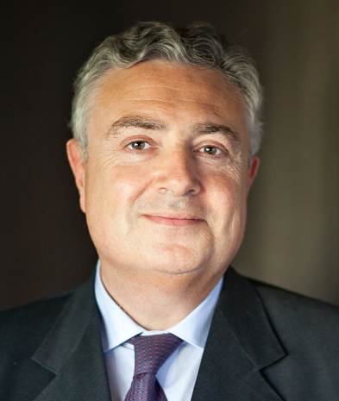

Jacques CREYSSEL
Director General (CEO) of the French retail federation (FCD)

BIOGRAPHY
Jacques Creyssel was born in 1956

EDUCATION
1978-81: Graduate of the « École Nationale d'Administration » (ENA)
1976: Graduate of the « Institut d'Etudes Politiques » (IEP) in Paris

CAREER
- 1981-1985: Civil administrator. Responsible for the budgets for transport, civil aviation and meteorology in Budget Department, Ministry for Budget affairs
- 1985-1987: Deputy Head of the operations and financial information within the COB (French financial authority)
- 1987-1992: Head of the Department for Housing finance, environment, spatial planning, tourism and planning of the departmental budget; and then from 1991, Deputy Director in charge of wage policy and employment for the civil service and public enterprises
- 1993-1998: Director General for Economic Affairs; and then from 1996, Director General for Economic Affairs and strategic coordination of the French national business and employers organization (CNPF)
- 1998-2008: Managing Director and CEO of the Mouvement des Entreprises de France (MEDEF)
- 2004-2010: Member of the French Economic and Social Council (CESE)
- Since February 2011: CEO of the French retail federation (FCD)

MANDATES
Member of the Board and of the Executive Committee of the French national business and employers organization (MEDEF); Chairman of the Committee on Economy, Competitiveness and Finance; Chairman of the Competition and Consumer Affairs Committee
Vice-President of the French trade and retail council (Conseil du Commerce de France)
Vice-President of EuroCommerce
Vice-President at the Federation of International Retail Associations (FIRA)

OTHER
Professor at the « Institut d'Etudes Politiques » (IEP) in Paris.

